Addressing Recruitment Discrimination: How Enterprises Ensure Fairness in the Recruitment Process

Abstract
This study examines employment discrimination in Chinese technology companies' recruitment processes through a critical realist lens, challenging conventional theories that frame discrimination as individual prejudice or market inefficiency. Using qualitative semi-structured interviews with six participants representing diverse demographic combinations, this research reveals discrimination as a systematic social reproduction mechanism serving multiple structural functions beyond mere bias.
The findings identify five key themes: the "35-year wall" demonstrating age-based exclusion mechanisms; gendered technical competence revealing patriarchal gatekeeping; educational elitism functioning as class reproduction through credentialism; intersectional discrimination creating compound disadvantages; and organisational responses characterised by symbolic compliance rather than systematic change. The study demonstrates how age discrimination serves workforce control purposes, maintaining cultural homogeneity while suppressing wages. Gender discrimination adapts patriarchal structures to preserve masculine dominance despite women's proven competence. Educational discrimination reproduces class hierarchies through institutional prestige preferences regardless of actual capability.
Critically, intersectional analysis reveals how multiple oppression systems interact synergistically rather than additively, creating qualitatively different experiences that single-axis frameworks cannot address. Organisational diversity initiatives largely function as legitimisation mechanisms, providing legal and social cover while structural inequalities persist.
The research contributes theoretically by exposing discrimination's systematic functions in hierarchy maintenance and practically by demonstrating why traditional diversity interventions fail. Results indicate that effective change requires structural transformation aligning inclusion goals with organisational power interests rather than voluntary compliance measures. This study advances critical understanding of technological capitalism's role in inequality reproduction, challenging assumptions about innovation's democratising effects.

Chapter One: Introduction

Background
China is a state of paradox in its technological sphere because the dynamic economic growth is interconnected with long-term structural disparities that undermine the traditional discourse of merit-based promotion. Although the digital economy achieved 45.5 trillion yuan in 2021, or 39.8% of the GDP of China (Jiang and Murmann, 2022), the impressive growth belies the underlying structural contradictions that underscore the constraints of the market-based approach to social inequality. In their study, Baker and Welter (2024) argue that, the fact that the sector employs more than 7 million professionals of various speciaalizations paradoxically evidences not only an unprecedented creation of new opportunities but also widespread practices of systematic exclusion that contradict the endeavours of the industry to talk about its commitment to innovation and talent optimization.
More importantly, this whole self-image of the technology sector as a meritocratic and progressive industry runs deeply counter to real-world observations with systematic discrimination across the organizational structure and types of companies. This dichotomy indicates the inherent conflict between capitalist demands of competitive advantage by talent acquisition and underlying cultural inclinations rooted in discrimination against access to opportunities on the basis of traits with no relevance to the ability to perform well (Baker and Welter, 2024). The realities of the "war of talent" discourse used in the industry cover more complex forces where a falsely cast notion of talent shortage sits along with the exclusion of the talent based on lack of fit to the restrictive demographic parameters.
The continued occurrence of discriminatory practices in China's technology sector undermines conventional theoretical models that presume competition in the marketplace would eradicate inefficient practices such as employment discrimination. Rather, the evidence also indicates that discrimination possesses latent purposes such as maintenance of social status, risk mitigation, and homogeneity of culture, which transcends the factor of economic efficiency (Wang et al., 2021). This process raises an important question of whether technological innovation is always likely to be associated with social progress, or whether it is possible that digitization can be pursued along with reproducing inequality.

Problem Statement
Discrimination in the workplaces of Chinese technology companies is an essential market failure to stamp out inefficient behaviour and reflects the opposite of neoliberal assumptions about the system of competitive markets and their self-correcting nature. In spite of the force of law and corporate diversity rhetoric, systematic exclusion on the basis of age, gender, and educational experience remains largely intact because it has its own uses despite being ostensibly little more than bias or ignorance (Zhang et al., 2021). This insistence requires a critical consideration of the nature of discrimination as a structured process of perpetuating the hierarchical patterns of things in the supposedly meritocratic organisational environments.
In the experience of recruitment discrimination, it is clear that there are subtle systems at work whereby discriminatory effects are brought about by non-discriminatory systemic procedures (Stypinska, 2022). Discrimination based on age often occurs in the form of the so-called 35-year wall when ageist bias about technological literacy is institutionalized by means of the informal but highly influential cultural norms overriding individual evaluation of performance (Stypinska, 2022). The institutionalization implies that discrimination does not only qualify as personal prejudice but as institutionalized rejection that fulfils wider social and economic roles.
Even when women are very well or equally educated in the technical sector, gender discrimination still remains, as evidenced in how the patriarchal structure adapts to the evolving technologies of higher learning, with males still dominating the technical positions of upper statuses. The persistence of exclusion of talented, progressive women reveals the inherent inconsistencies of meritocratic ideology and patriarchal preservation of legacies that technologically oriented corporations mitigate in thin but promising discriminating modalities of practice (Liu, 2024).
Educational discrimination is uniquely suited to demonstrate the process of reproduction of cultural capital in the form of participation in the labour force, despite the fact that by all available evidence, education becomes a means of reproducing cultural capital to the disadvantage of students with non-elite backgrounds, regardless of their real abilities or possible contributions. The preference of university graduates of prestigious universities also shows how social reproduction occurs at the level of institutional hierarchies in education, about which technological companies do little, except support it (Lu et al., 2022).
Most importantly, the intersectional characteristics of these discriminatory practices compound the disadvantages in more significant ways than the additive effects, and this is how various experiences of oppression interrelate to produce distinct hurdles to people who belong to more than one marginalized group at the same time (Collins et al., 2021). This encapsulation between two axes shows how one-dimensional concepts fail to comprehend and do anything about employment discrimination.

Comparative Context: Global Technology Sector Discrimination
Chinese technology firms are supported by cultural and institutional environments that can normalize or legitimize biased acts to a higher extent, unlike in cases of the technology sector in Silicon Valley, which is subjected to notable regulatory intervention and social inquiry that calls to account inequity provisions (Baker and Welter, 2024). Whereas shareholder activism, media attention, and legal pressure on diversity outcomes provide an effective deterrent on US technology companies against more overt discriminatory conduct, the existence of systematically less external pressure on Chinese firms to perform inclusively may allow more overtly discriminatory behaviours to be practiced.
Baker and Welter (2024) argue that, the European technology markets exhibit other solutions in the form of more robust regulatory regimes and cultural norms that focus less on pure marketplace competition and more on social solidarity, and hence it is possible that levels of discrimination might change with societal attitudes towards inequality and regulation as broader concepts, and not necessarily as a factor of industry characteristics. The case of comparison between European social market economies and Chinese state-directed capitalism works well; this is because it seeks to explain how institutional arrangements distinctly determine the nature of discrimination in societies, even when similar technological backgrounds exist (Collins et al., 2021).

Research Questions and Theoretical Positioning
This study adopts a critical realist approach to examine three interconnected research questions that challenge conventional assumptions about discrimination causation and intervention in Chinese technology companies:
- Research Question 1: How do age, gender, and educational discrimination function as systematic social reproduction mechanisms in Chinese technology companies' recruitment processes?
- Research Question 2: How do intersectional discrimination effects create compound disadvantages that reveal the inadequacy of single-axis theoretical frameworks and intervention strategies?
- Research Question 3: What structural contradictions limit the effectiveness of organisational diversity interventions in addressing systematic discrimination in Chinese technology firms?
These questions critically interrogate how intersectional forms of discrimination systematically reproduce social hierarchies within recruitment processes, moving beyond individual bias explanations to examine structural mechanisms that maintain inequality. The first question explores how age-related biases, gender stereotypes, and educational discrimination operate as systematic mechanisms serving broader economic and social functions rather than mere prejudice. The second question examines how multiple forms of oppression interact to create qualitatively different experiences that cannot be understood through additive models, revealing the limitations of traditional single-axis approaches. The third question investigates the fundamental contradictions between stated diversity commitments and structural imperatives that perpetuate exclusionary practices, examining why organisational interventions often fail to address systematic discrimination.
This critical realist framework positions discrimination as an emergent property of structural configurations rather than individual attitudes, necessitating analytical approaches that examine how organisational cultures, economic forces, and social stratification interact to create patterns of systematic exclusion that persist regardless of individual intentions or official policies.

Research Approach and Contribution
This research adopts a critical qualitative approach in extending the study of discrimination as a patterned social process, as opposed to the internal psychological prejudice within a person and challenging major theories according to which the discrimination process can be viewed as an individual attitude but not as a structural arrangement (Pimentel, 2024). The study uses the critical realist epistemology to explore observable patterns of discrimination, deep-seated structural processes and contradictions that create unsurpassable inequality regardless of changes in organizations.
This study has been a valuable addition to the literature on intersectional discrimination in China in technology spheres as it has been able to systematically analyze the intersections of discrimination in various areas, thus translating into a combination of disadvantages greater than the mere sum of their prejudices. As opposed to descriptive studies of the actual presence of discrimination, the study is critical to illustrate how the discriminatory practices are used to fulfil larger interests such as maintenance of social hierarchy, cultural homogeneity, and economic risk management, which trumps efficiency considerations.
Theoretically, the study confronts propositions of mainstream frameworks that view discrimination as a form of market inefficiency that is removed with competition, but rather constructs the evidence that discriminative practices can have underlying functions that mean that they proceed to endure dissimilar expectations despite the perceived burdens. Practically, the critical analysis in the study explains why traditional derivations of alleviating the ills of diversity do not provide solutions to the structural bases of discrimination, which implies further overarching change at organizational and societal levels.

Thesis Structure
This thesis dismantles the very phenomena of discrimination by Chinese technology firms critically by going beyond the descriptive documentation to the underlying structural processes and contradictions. Chapter Two presents the drawbacks of the theoretical frameworks in a critical way and finds that discrimination has more purposes than mere bias or ineffectiveness. Chapter Three will present the critical realist approach that allows analysis of discrimination as a structural social phenomenon. Chapter Four comes up with a critical analysis of empirical evidence that exposes the structural basis of discrimination. Chapter Five critically reads results in terms of relations that transcend the subject theory and comparative context. The latest chapter, chapter six, builds on critical suggestions to counter the structural foundations of discrimination instead of focusing on the superficial forms of discrimination.

Chapter Two: Literature Review

Theoretical Framework Critique and Limitations
The general theoretical explanations used to explain employment discrimination have a serious epistemological weakness that limits their validity and applicability. The Social Identity Theory, Resource Dependence Theory and Signalling Theory all hold some truths and at the same time hide the critical structural processes that sustain systematic inequality in organisational settings.
The interest in psychological processes of the Social Identity Theory makes discrimination phenomena inherently individual, with the bias shifting to the cognitive level instead of focusing on the construction of the organisational structure and economic system incentives to use discrimination (Hassler et al., 2021). This lack of psychology reduces the fact as to why discrimination exists in various individual decision-makers and organisational contexts, thus portraying a possibility that systematic exclusion may be a structural factor as opposed to psychological. The complexity of power relationships has been underlined through the theory of in-group favouritism and out-group contempt, which simplifies underlying power dynamics that develop an organisational hierarchy and distribution of organisational resources.
Importantly, the psychological principle behind Social Identity Theory, i.e. discriminations exist due to the natural psychological tendencies, deprives the lack of understanding how these social categories themselves are instituted and perpetuated by institutional practices and are not natural divisions among innate human beings (Nils Karl Reimer et al., 2022). The theory does not explore the ways that organisational cultures, recruitment practices, and performance appraisal systems actively create and sustain the boundaries of groups which seem natural entities, but in fact have definite social and economic roles.
The structural focus in Resource Dependence Theory offers new insight into organisational behaviour that ultimately accepts capitalist logics that place less stock on social justice and focuses more on capitalist logic under the guise of efficiency and competitive advantage (Davis and DeWitt, 2021). The rational model predication of the theory that organisations aim at rational maximisation of resources in maximising what they deem as value overlooks the fact that definitions of value itself are refractive and reproductions of relations of power instead of implying objective evaluations of potential contribution.
The drawback of the theory is that it does not look into the process of cultural construction of resource calculations, instead of examining them objectively, which results in systematic underestimation of skills attributed to marginalised groups and overestimation of those belonging to the dominant ones (Jiang et al., 2022). Such cultural construction of value makes discrimination seem rational and instead plays the roles of maintaining social hierarchy, superseding considerations of efficiency.
Jiang et al. (2022) is his study adds that, Resource Dependence Theory is unsuccessful too in clarifying the ways in which power disparities between organisations and job seekers facilitate discriminatory practices even without considerations being given to their implications for efficiency. In the theory, there is an assumption of mutual dependence between resource providers and organisations, largely disregarding the way labour market systems of dependencies facilitate systematic exploitation and exclusion of some groups.
The Signalling Theory approach to information asymmetry is also consistent with the logic of the market but does not analyze the systematic disadvantaging of some groups of people based on the mechanisms of signalling processes, which are not limited to information problems (Connelly et al., 2024). The theory presupposes that signals are quality referring postulates by neglecting the way opportunities to acquire signals tend to be systematically allocated across the social class, gender, and race systematizing inexistence in existence terms.
More importantly, Signalling Theory does not analyze the cultural construction of signal interpretation processes as opposed to crowd-free processes, which results in systemic over-processing in cases where the interpretation process applies to signals of dominant groups, and under-processing in similar signals of marginalized groups (Connelly et al., 2024). This interpretive bias will allow discrimination to work through seemingly neutral credentialing processes, but generate disproportionate and systematically inequitable results.
The limit of the theory is the fact that it does not look into how signalling requirements themselves can be unnecessary or counterproductive to effective job performance; therefore, signalling processes may have their roles in social practices of sorting instead of measuring quality (Connelly et al., 2024). Educational credentialism is an example of the inefficiency of signal requirements, as it may give systematic disadvantages to qualified applicants by failing to predict job performance sufficiently.
Figure 1 Systematic Discrimination Mechanism Flow.
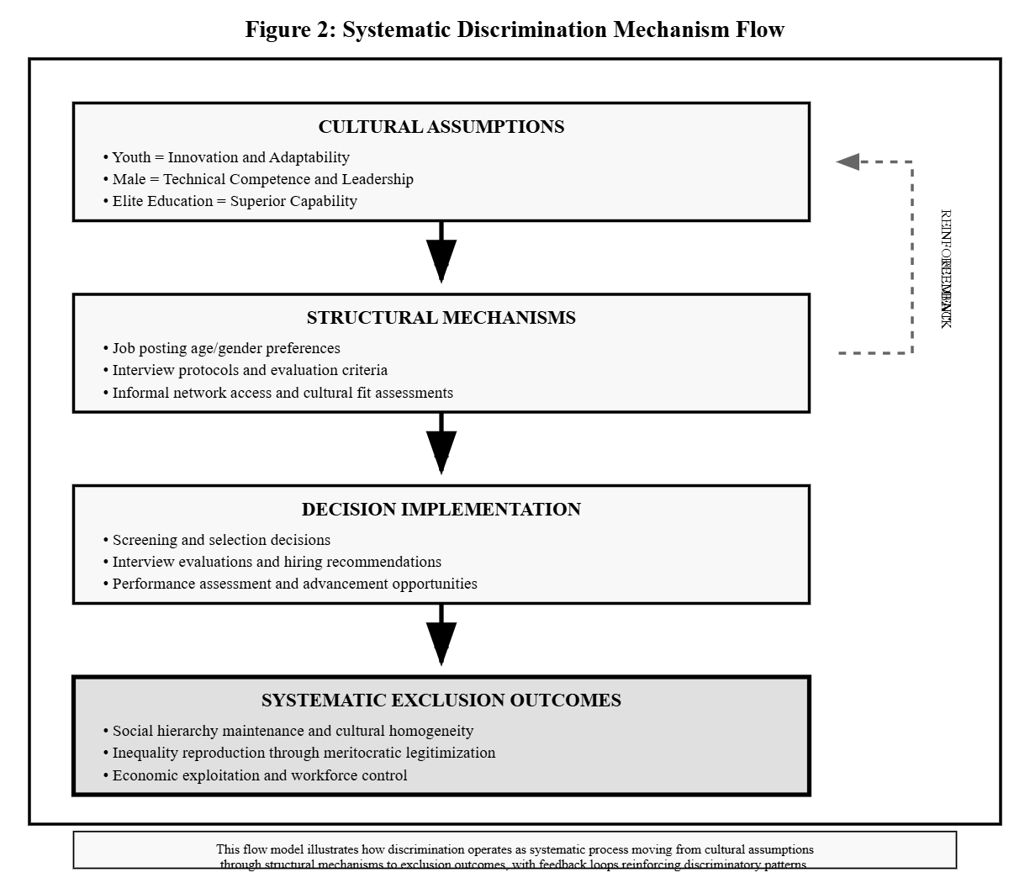

Critical Analysis of Discrimination Research Paradigms
Prior studies on the phenomenon of employment discrimination in Chinese technology companies are faulty on methodological nationalism that does not place localisations in a wider context of technological capitalism and reproduction of social inequality on a global scale. The majority of the studies approach Chinese discrimination patterns as exclusive cultural phenomena instead of analysing how the global systems of economies and the technological models of economic growth contribute to the same exclusion patterns in various national contexts (Kam et al., 2022).
The bias towards quantitative outcomes over qualitative process measurement inherently hinders an explanation of the ways discrimination works due to the use of subtle mechanisms that do not show an immediate measurable result, but still lead to a measurable difference over the long term (Muzari et al., 2022). Such methodological prejudice in favour of what can be measured leaves out how discrimination operates via cultural processes of subordination, informal contacts, and ostensibly neutral routines that systematically favour some groups over others.
Gender discrimination studies show such methodological constraints because they often concentrate on the numerical presence of men or women in an organisation as opposed to analysing the manner in which masculine organisational cultures disadvantage women due to systematic processes that go beyond recruiting gaps into areas long since ignored (Kam et al., 2022). The concentration on pipeline issues and professional training overlooks the prior establishment of workplace cultures, informal systems of associates, and promotion practices, which present obstacles that cannot be broken down by the educational levels obtained by women or their initial success in the employment.
More importantly, gender discrimination studies do not necessarily document the process through which technological work is culturally comprised as masculine or how the technological work is culturally comprised as masculine through past progression associated technical skillness with masculine features in place of thinking of these attributes as socially constructed objects that have their purposes in mental maintenance (Kam et al., 2022). Such naturalisation of masculine technical mastery masks the workings of gender discrimination as a form of cultural evaluation and discrimination other than through the evaluative lens of objective skills.
Research on age discrimination is also subject to individualist bias, which attributes ageism to an aspect of attitudes instead of looking at the way organisational patterns and economic demands establish structural motivations to age-based exclusion that are independent of individual attitudes (Stypinska, 2022). The emphasis on attitude transformation overlooks that age discrimination can have a variety of purposes, such as controlling costs of wages, maintaining cultural homogeneity, and signalling of innovation, and these purposes trump individual bias concerns.
Perhaps the most considerable theoretical blindness can be seen on the case of research of educational discrimination intending that it is often acceptable by meritocratic ideology that sees educational accomplishments as a justified ground for hierarchy in the work place instead of questioning how, in fact, educational systems, justify the production of advantage in social hierarchy through a mode of reproducing guides that are not subject to the notions of individual merit or effective work (Kiran Marlapudi and Lenka, 2024). The assumption of meritocracy, rather, does not reflect the workings of educational credentialism as a form of social sorting mechanism that has legitimised inequality and which has not forecasted job performance experiences.

Intersectionality Theory: Beyond Single-Axis Analysis
The theory of intersectionality offers significant insights that refute the use of single-axis frameworks of discrimination and define the interdependence of various forms of oppression to build up the unique experiences that cannot be explained in terms of adding on to one another (Collins et al., 2021). Nevertheless, intersectionality studies within the organisational setting can be descriptive without engaging in critical analysis of how intersectional discrimination functions in systematic ways that perpetuate multi-dimensional hierarchies that uphold the interests of dominating groups at any one time.
Applying the theory of intersectionality to discrimination in the technology industry benefits because it helps expose how ageism, sexism, and educational elitism are systems that interact with each other and not inseparable biases but to the benefit of each system with the additional disadvantage being a benefit to the social reproduction of a larger picture (Goggin and Soldatić, 2022). This regular communication implies that discrimination-based interventions that focus on individual types of bias are basically inadequate, irrespective of whether they are well-designed or not.
Importantly, an analysis of intersectionality demonstrates that people who belong to two or more marginalised groups encounter a set of disadvantages that go beyond the product of discrimination against single-axis groups, but produce qualitatively different experiences that must be analysed through different lenses and addressed in different ways. The experience of older women with a non-elite educational background demonstrates how intersectional discrimination produces win-lose situations that cannot be solved by traditional diversity practices.
Figure 2 Critical Theoretical Integration Framework.
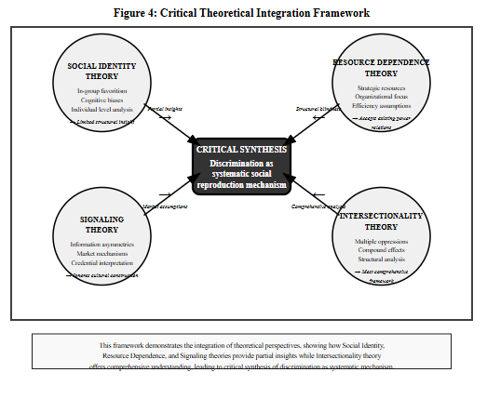

Comparative Global Analysis: Technology Sector Discrimination Patterns
A comparative analysis of different technological capitalism models shows dramatic differences in the patterns of discrimination, which calls into question preconceived notions of an inherent association between technological progress and social equality. The technological industry of Silicon Valley shows the example that market-based innovation can exist in parallel with inequality, even amid great diversity rhetoric and investments in intervention (Baker and Welter, 2024).
Industries in Europe that work under the regulations of a social market economy depict other ideas that put more emphasis on social cohesion, as well as technological development, indicating that the level of discrimination and indeed any technological housing industry is related to the broad institutional establishment but not the area of the industry (Kam et al., 2022). The comparative approach to inclusive practices of Nordic technology companies and the exclusionary orientations manifested by Chinese-based companies demonstrates the diverse implications of the various capitalist models in providing avenues and limitations of the discriminatory nature of conduct (Kam et al., 2022).
Nevertheless, convergent patterns of discrimination reproduction seen in comparative analysis show a possibility of systematic pressures in technological capitalism toward the maintenance of inequality independent of national or cultural context. Global trends in ageism in the areas of technology suggest that competitive pressures and a technologically changing world influence the establishment of similar exclusion patterns in various institutional contexts (Baker and Welter, 2024).

Critical Gaps in Existing Literature
The major shortcoming in the current studies of discrimination is the absence of the investigation of the discriminatory practices benefiting the rest (social and economic) processes in the society, despite its inefficiency. Studies that approach discrimination as mere irrational bias cannot explain why systematic exclusion continues across various organizational settings and different decision-makers, hence necessitating a structural study which can examine functional aspects of discrimination.
The lack of critical analysis of the topic in which discrimination contributes to class reproduction, maintenance of patriarchy, and homogeneity of cultures is one of the theoretical drawbacks that narrow the possibilities of developing practical intervention. Otherwise, intervention strategies to eliminate discrimination will be bound within the surface-level processes since there is no knowledge of the systematic functions of discrimination, and thus, there are no interventions that genuinely tackle the structural foundations of discrimination.
Methodologically, the major outcomes measure concentration instead of a somewhat focused process on qualitative analysis, which essentially restricts comprehension of how discrimination functions through cultural devices, informal ways and the apparent unbiased procedures that generate systematic benefits and losses. This method of bias gives the appearance of the subtle nature of discrimination and exaggerates dramatic differences that only cover the tip of the iceberg of discrimination.
The paucity of focus on the intersectional discrimination in the context of technology is both a theoretical and practical constraint that impedes the realization of the complex ways in which various types of oppressions intersect and how we may intervene on behalf of the people who operate under compound disadvantages. Single-axis methods inherently miss the complexity of discrimination functioning with the generation of interventions that tend to deal with only a part of the picture of systematic marginalization.

Chapter Three: Research Methodology & Methods

Critical Realist Philosophical Foundation
This research embraces critical realist epistemological approach, which criticizes both the positivist beliefs about objective social reality and interpretivist beliefs about subjective construction of meaning, and instead takes discrimination as systematic social phenomenon acting through structural mechanism that exist beyond the awareness of individuals and acknowledges that the mechanism itself needs to be interpreted by individual lives (Sayer and Morgan, 2022). Critical realism will allow analyzing the visible forms of discrimination, their predisposed distributions, and patterns of structural operations that create unequal balance in organizations, even with the attempt at change.
The stratified ontology of critical realism, on the other hand, provides the ability to analyze the settings of empirical experiences, actual events, and the underlying structural mechanisms in order to understand and analyze underlying ways of criticism and tendencies that produce patterns of discrimination (Pimentel, 2024). This school of thought questions dominant sets of thinking which either view discrimination as a psychological matter and inclination on the part of individuals, or as a matter of simple quantifiable consequences, by considering how the structural set-up fosters systematic inclinations to discriminative behaviour.
The critical realist approach allows us to study discrimination as the consequence of structural set-ups rather than mere summation of personal prejudices, to understand how organizational cultures, economic forces and status differentials work together to establish patterns of systematic exclusion that recur in interventions of distinctive individual decision-makers and in various organizational settings. Such structural orientation contradicts individualistic approaches to intervening, whereas postulating the necessity of systematic change, which can be aimed toward the roots of the problem of discrimination.
Methodologically, critical realism facilitates retroductive inferences that would start with observable patterns to theoretically analyze the underlying structures by predicting the coherence pattern and analyzing it in a systematic way, without disengaging empiricism's obsession with coincidence patterns and idealism's obsession with subjective interpretations (White and Cooper, 2022). The method allows for the development of an explanation which takes into account the existence of discrimination and its persistence despite the seeming inefficiency and action.

Qualitative Methodology: Beyond Descriptive Documentation
The study adopts qualitative research methodology to not only record discrimination experiences but also to achieve a critical understanding of how systematic rejection is achieved through cultural and informal processes and through seemingly non-discriminatory processes that add up to repeated disadvantages over the life course (Flick, 2022). The qualitative approach will make it possible to analyse the invisible and latent mechanisms of discrimination by looking through processes that go beyond objective results to incorporate relations between and amongst people and social institutions that systematically raise a few and lower others as society continues to evolve.
The problem of the qualitative focus with quantitative methods lies in the fact that they narrow down discrimination to the areas of measurable disparities without taking into account the mechanisms underlying processes that cause systematic inequality and perpetuate it. The qualitative methodology will help to critically look at the manner of functioning of exclusionary forms of practising as republics that might be using apparently neutral structures that conceal discriminatory aspects, whilst being able to mask themselves as plausible deniability on the part of the organisational actors.
Qualitative methodology allows studying interactions and intersections of discrimination effects that introduce distinctive experiences to members of several marginalised categories and makes clear the way various manifestations of oppressions can interact with each other in a fashion incapable of being measured with quantitative techniques that have a single-axis focus (Staller, 2022). This intersectional concern necessitates methodological flexibility that is capable of adjusting to dissimilar and developing structures instead of testing previous conclusions regarding the particular effects of discrimination.
The methodological focus is on critical analysis as opposed to descriptive documentation, which sets out to explore how the experiences reported by participants divulge larger structural processes and contradictions as opposed to merely describing different experiences of discrimination as encounters. Such critical attention facilitates the creation of theoretical understanding that is no longer limited in its application to given organisational situations but provides an understanding of general patterns and processes that take place across a range of organisations.

Semi-Structured Interview Method: Critical Dialogue Approach
The semi-structured interviews facilitate a critical discourse that renders a deeper look than mere experiences to study the structural processes and contradictions that create patterns of discrimination and leverage the insights provided by the participants to achieve theoretical knowledge of how the systematic exclusion plays out via the apparently rational operations within the organisation (Flick, 2021). The method of interviewing will allow exploring the process in which the subjects perceive the structural limitations and cadres and negotiate them to prompt the manifestations of conflict between organisational discourse and actions.
Its semi-structured form allows systematic coverage of main theoretical topics and topics being discussed, while retaining flexibility to discuss unexpected insights and inconsistencies that arise in the dialogue, and as such, neither the rigid and structured approach to interviews that limit the exploration nor the unstructured approach that lacks theoretical considerations is pursued. This compromise allows launching advanced theoretical observations, keeping in touch with the opinions of the participants of the research and empirical themes.
The questions presented in interviews are written to lead to a critical thinking process of the experience related to discrimination, which does not precondition participants to arrive at the conclusions guided by questions, but allows them to explore the patterns through which systematic exclusion on discriminatory grounds is achieved and that are not necessarily perceived as such by the participants. Such a method shows how discrimination may be evident in unobtrusive ways but gives its subjects the opportunity to gain a critical awareness with regard to the experiences.
The dialogue method allows exploring the ways in which subjects resist, comply with and negotiate discriminating systems, as well as uncovers incompatibility between individual agency and structural factors that restrict possibilities to effect changes in a meaningful way. Such interest in interaction between agency and structure allows for the development of subtle knowledge that does not focus on individualistic blame and structural determinism.

Purposive Sampling Strategy: Theoretical Diversity
In purposive sampling, diversity is first and foremost theoretical and not statistical in that the studied population will be composed of participants whose diverse demographic values and organisational experiences allow exploring the various discrimination mechanisms and intersectional effects (Guest et al., 2020). The sampling criterion will focus on a maximum variation of age, gender, educational background, and organisations so that a comparison can be done based on how discrimination can work in different ways in different mixtures of these determinants and environments.
The sample will contain six people with different demographic combinations that will allow considering the discrimination effects of interlocking rather than considering different types of bias as dissimilar forms. The determination of participants gives emphasis on the acquisition of theoretical insights rather than generalisation in statistics, with an interest in instances that can shine light on various predictors of systematic exclusion and comparative analyses of patterns of different discrimination patterns.
Participants are chosen based on their experience, bringing a broader pattern and mechanism into focus, instead of focusing on an individual situation, selecting those whose experience will be most representative of patterns and mechanisms. Although the use of sampling decisions shows significant priorities of what is thought to be of critical theoretical concern, it is whether the theoretical critique reveals structural analysis or presents the experience of an individual. This type of theoretical emphasis allows building of knowledge elements that are not contextual in a particular organisation but rather expand beyond this and equally not confined to anecdotal studies that also restrict the analysis in terms of generalizability.
The range of organisational contexts represented can be used to look at how such different types of companies, different ownership and market positions pose different constraints and opportunities on discriminatory behaviour, so as to be able to show how the broader forces of the economy and the institutions of the market relate to discrimination patterns in different organisation types.

Thematic Analysis: Critical Pattern Identification
Thematic analysis shifts the focus of descriptive theme identification towards an analysis of patterns through which unseen structural mechanisms and contradictions that create systematic exclusion can be discovered (Nieman, 2023). The critical interpretation that enables insights into the ways in which surface phenomena can represent more fundamental structural arrangements is of primary importance in the analytical approach rather than merely cataloguing the experience of the participants or revealing those themes.
The theoretical sensitivity applied in the analysis involves already defined frameworks that it uses to direct identification of patterns, but also allows those of a contradictory nature as well as contrary insights, thus challenging preset assumptions. It is this compromise between theoretical orientation and empirical openness which permits the development of sound insights which is beyond the currently available knowledge, but without lapsing into pure inductive methods which are not theoretical in nature.
The processes of coding focus on the critical analysis of the way in which experiences of participants allow understanding the larger structural processes that might not be involved in the straightforward classification of individual viewpoints or experiences. The coding method helps find patterns that expose the systematic workings of discrimination, even as contradictions and tensions are spotted that get to the dynamics of the structural workings.
The development of theme is also a theoretically significant notion instead of being descriptively accurate, whereby patterns are identified and used as instruments that impart significant insights regarding the structural basis of discrimination and not just describe the views held by the participants. This methodological emphasis permits the construction of vital analysis that includes surprising semantics and, at the same time, correlates with empirical information.

Reflexivity and Critical Positioning
This study is based on the recognition and acknowledgment of the positionality of the researcher within the wider social context, but also focusing on the ways in which this positioning facilitates and limits critical reflection of the phenomena of discrimination (G Instead of unreliable objectivity that is highly speculative to achieve, the research will employ critical reflexivity, which looks at the role of the researcher background, theoretical commitments, and institutional positioning to impact the nature of analytical perspectives with the help of which analytical bias can be better here an improved not eradicated.
This sensitivity of the researcher to the operation of discrimination, given his adherence to social justice and inequality reduction, may be both analytically sensitive to discrimination as a way of operating and limiting the identification of discrimination as it is functioning or in organizational opinions that justify exclusionary practices. This tension needs to be a matter of constant reflexive reflection that investigates the ways in which normative commitments both facilitate and inhibit critical comprehension.
Methodological reflexivity focuses on the nature of such theoretical and political concerns appearing in research design, data collection methods, and analytical practices as being principled choices rather than objective technical decisions and uses this understanding to achieve greater analytical clarity when taking into account the variously political character of research as a whole. This reflexive methodology is critical of positivist beliefs of value-neutral research and has a compact adherence to analysing rigour and empirical evidence.

Limitations and Methodological Constraints
The qualitative orientation of the study provides the opportunity to study the structural actions of discrimination in-depth, but it restricts the possibility of generalising the statistics of discrimination occurrence or scale within the general population (Kunisch et al., 2022). The methodological decision is skewed toward the generation of theoretical understanding instead of empirical generalisation, where the importance is on the process rather than the measurement of discrimination extent or frequency of occurrence.
The purposive sampling method allows exploration of wide discrimination situations and creates the possibility of over-representing the people who are ready to share on the sensitive types of situations and may exclude the views of those who feel comfortable with discrimination arrangements without acknowledging and/or defying them. This sampling bias can be a handicap to the knowledge of the working of discrimination when it is normalized or when affected people are not aware of its existence.
The cross-sectional research design gives information about the present discrimination scores, and it does not give comprehensive information about the trends of the discrimination as time changes or even in response to different organisational circumstances and the economic changes. Longitudinal analysis would provide a better comprehension of the dynamic nature of discrimination, as well as allowing the study to trace how such intervention efforts may influence the practices excluding others.
The emphasis on individual experiences can take the readers one step closer to the reality of discrimination, but it might also restrict what is understood about the way decisions are made, the structure, and the institutions that influence how management behaves in a discriminatory fashion. Organisational and institutional investigatory analysis would support a better explanatory way of looking at how discrimination works systematically.

Chapter Four: Results/Findings
As per the thematic analysis, five essential aspects of systematic discrimination emerge to demonstrate key contradictions between meritocratic ideology and exclusionary process in the context of Chinese technology companies. These results show that discrimination is a highly intricate system of reproducing social ranking as opposed to mere personal preferences and display structural tendencies through which they fulfil wider purposes, such as ineffective personnel choice.

Theme 1: The "35-Year Wall" - Systematic Age-Based Social Reproduction
The institutionalisation of age discrimination, even in the form of the so-called 35-year wall, demonstrates complex systems of maintaining organisational cultures that prioritise the alleged ease of adaptation instead of accrued experience, whilst performing subsidiary roles such as control of wage bills and increased disposability of workforce. This form was also a tradition of systematic exclusion, performed using apparently logical reasoning, masking ageist suppositions and economic exploitation necessities.
The experience of participant B sheds some light on how age discrimination is a form of systematic exclusion rather than a form of prejudice tied to the individual:
"The moment HR hears I'm over 40, their entire demeanour changes. It's not personal prejudice - it's systematic policy disguised as preference. They've institutionalised age limits to maintain low wage costs and workforce flexibility, not because younger workers are actually more capable." [Participant B]
This understanding demonstrates how age discrimination performs economic purposes that supersede individual appraisals of competence whilst remaining valid thanks to the marketing of innovation.
This interplay between ageism and family status demonstrates how patriarchal presumptions about male breadwinner work necessitate even more depths of systematic exclusion in a supplementary development of age bias that goes past easy ageism.
"Being married with family responsibilities makes me doubly problematic - they assume I'm less flexible due to age and less committed due to family obligations. It's a systematic trap where traditional masculine expectations become grounds for professional exclusion." [Participant D].

Theme 2: Gendered Technical Competence - Patriarchal Gatekeeping Mechanisms
Gender discrimination is a complex process that ensures that the masculine hegemony in technical positions remains intact in spite of women's proven competency, and this shows how a patriarchal culture is able to accommodate changes in the education systems and yet ensure the basic power relationship by expressing it through subtle yet effective exclusionary behaviour.
Participant A’s story shows how gender bias can be exercised by way of systematic competence for questioning which leads to eroding women’s professional credibility:
"In technical discussions, my suggestions face additional scrutiny that men's identical ideas don't encounter. It's not overt rejection - it's systematic doubt that requires constant capability demonstration. This extra burden exhausts women while appearing neutral to outside observers." [Participant A]
This observation shows how gender discrimination works based on ostensibly objective quality evaluation procedures that systematically discriminate against women who can still claim to have a plausible deniability.
The gender and age intersection presents especially complicated patterns of discrimination that show the mechanised exclusion of women as the systematic function of patriarchal assumptions regarding the priorities in their lifecycle.
"As I approach 35, employers increasingly view me through biological determinism - either too career-focused to be properly feminine or likely to abandon work for family. Elite education intensifies rather than eliminates this scrutiny because it signals threatening ambition." [Participant E]
This dynamics expose how the notion of achievement paradoxically turns out to become a liability when it contradicts the expectations of the patriarch that define what is expected of women in terms of how they ought to behave.

Theme 3: Educational Elitism - Cultural Capital Reproduction Mechanisms
Educational discrimination can be seen as a refined form of the class reproduction process, which justifies the inequality through meritocracy-based ideology and, at the same time, due to the inequality, undereducates candidates in literally all situations in comparison to others with similar or higher institutional prestige regardless of their potential or ability in a given capacity. This marginalisation fulfils other functions related to the maintenance of the class hierarchy that go beyond discrimination in the quality analysis.
The experience of participant D throws some light on the functioning of educational bias as systematic exclusion through classes:
"Junior college background immediately signals 'lower class' regardless of actual skills or achievements. It's not about capability assessment - it's about maintaining social hierarchies through credentialing systems that preserve elite advantages." [Participant D].
This fact shows the nature of educational discrimination as a form of gatekeeping instead of a quality evaluation process. The interactions among educational background and other demographic categories produce complex effects of discrimination that show the ways different systems of hierarchy can work together to produce complex situations of exclusion.
"Being over 40 with ordinary university background creates double disadvantage that extends beyond simple addition - it signals 'obsolete knowledge' and 'wrong class background' simultaneously, creating qualitatively different treatment." [Participant B].
This intersectional effect shows how disparate oppression systems bind together to build on top of one another, creating unique disadvantages.The way educational discrimination is carried out by seemingly objective assessment standards shows us how meritocratic ideology serves to rationalise systematic inequality, all the while concealing the reality of discrimination. The decision to focus on college rankings instead of real performance capacities clearly shows that credentialing systems are used to fulfil social sorting or serve quality evaluation purposes.

Theme 4: Intersectional Discrimination - Compound Oppression Systems
Intersectional discrimination leads to qualitatively new experiences exposing the insufficiency of single-axis theoretical structures, and also how multiple oppression systems combine to generate inter-multiplying disadvantages, which facilitate multifaceted hierarchy-maintaining purposes, at the same time.
The experience of unmarried woman with elite education close to 35 that is described by the participant E can be used to explain the way intersectional discrimination works in a specific way:
"My 985 degree should provide advantages, but combined with gender and age, it creates suspicion about ambition and family priorities. Elite education for women signals threatening competence rather than desirable capability, creating compound disadvantage that men with identical credentials don't face." [Participant E].
This experience demonstrates how success turns out to be a liability when it is inconsistent with various oppression structures at the same time. The combination of age, gender and marital status establishes no-win obligations to expose the highly sophisticated functioning of systematic exclusion through apparently conflicting demands such that exclusion in any of these occurrences is guaranteed by the demand of these varying options given. Single women are discriminated against because they are too focused on their career, married women are useless as they are busy with their family, and even divorced ones are unstable and are to be avoided, which shows the insurmountable standards patriarchal systems set and why they can be used to justify purges.

Theme 5: Organisational Responses - Symbolic Diversity and Structural Inertia
Diversity projects in organisations bring out inherent paradoxes by declaring some commitment to inclusion and some structural necessities that maintain the same exclusionary practices, as how diversity discourses further have legitimisation purposes, yet evading any real change that would call into question established hierarchies and power structures.
The evaluation of formal diversity policies conducted by participant A shows that it is symbolic, but not substantive:
"Written policies exist mainly for legitimacy purposes - they demonstrate good intentions without creating accountability mechanisms or measurable change requirements. HR departments lack power and incentives to challenge discriminatory practices that serve broader organisational functions." [Participant A]
This observation throws light on the role of diversity programs as institutional legitimisation process and not a systematic effort to change. The disclosure of the implementation gap between policies on diversity and practices indicates the way in which organisations retain exclusionary patterns of behaviour by evading responsibility by adopting the symbolic compliances. The lack of systematic measurement, accountability demand, and consequences system ensures the ongoing discriminative practices being able to present legal and social legitimacy through diversity rhetoric.
Blind hiring practices reveal the promise and the restriction of procedural interventions that can reduce the appearance of discrimination but they do little to interfere with the structural designs that sustain it.
"Technical assessments reduce obvious bias but don't address cultural fit assumptions, advancement opportunities, or workplace climate factors that systematically disadvantage certain groups after hiring." [Participant F].
This shortcoming demonstrates the ways discrimination fits within procedural constraints with a view to keeping results of exclusion intact via other modes. The difference in leadership commitment in organisations exposes the manner in which the issue of diversity results relates to the interests of holders of power instead of adherence to ethical obligations or efficiency. Organisations that realised the importance of diversity to business have more positive results than those that perceive inclusion as a moral duty, implying that there needs to be systemic change in such a way that they align with, rather than resisting, organisational power structures.
By showing the limitation of effectiveness to the training program, the inherent contradiction between the individual bias focus and structural discrimination reality is evident.
"Unconscious bias training assumes discrimination results from individual ignorance rather than systematic arrangements that serve organisational functions. Training fails because it addresses wrong analytical level while ignoring structural incentives for continued exclusion." [Participant E].
Through this observation, it is clear as to why person-centered programs cannot effectively challenge the structural bases of systematic discrimination.
Measurement and accountability systems hold promise of systematic change provided they are undertaken with a level of commitment and consequence systems, but show how window-dressing implementation can best serve legitimising rather than transformative purposes. Organisations that monitor the results without dealing with the underlying causes exemplify the extent to which measurement may become some sort of symbolic compliance as opposed to a business driver of change.
This fact, the contribution of outside pressure to encouraging organisational change, shows that discrimination decreases is only possible under the influence of the power of the stakeholders as opposed to moral awareness or efficiency issues. Participant E also observed that there are disparities among the foreign-invested firms that are in an international spotlight and the local companies where the international scrutiny is more or less non-existent, implying that systematic change cannot be easily achieved, but it needs an exogenous imposition.
Technological solutions to the mitigation of discrimination are promising and dangerous, as algorithmic screening can completely get rid of some of the human biases, but at the same time poses a risk of widening the systemic bias based on historical data to predict the past trends in discrimination. This idea that technology solutions bring objectivity overlooks how algorithms operationalise the same types of bias they seem to view as neutral, which could effectively turn technological authority into the same-old discrimination.

Chapter Five: Discussion

Critical Analysis: Discrimination as Social Reproduction Mechanism
The results radically dent the mainstream theoretical expectations concerning employment discrimination to demonstrate that systematic exclusion is a complicated process of social reproduction and not a manifestation of prejudice by individuals or statements of market inefficiency. Wang et al. (2021) argued that discrimination in the Chinese technology industries plays various roles such as enforcing hierarchy in the company, homogenising cultures and facilitating economic exploitation. The findings of this study help to prove this statement, as they illustrate the mechanism of the so-called 35-year wall functioning as the workforce control mechanism, which goes beyond the mere age prejudice.
As per the argument presented in the review done by Stypinska (2022), age discrimination is a systematic practice that props up organizational cultures that value perceived adaptability rather than experience-based knowledge. This analysis is furthered by the present findings, which demonstrate how the incremental age-based exclusion benefits the economy by allowing it to suppress wage levels and maximise the flexibility of the workforce. This mechanism is displayed by the experience of participant B:
" The moment HR hears I'm over 40, their entire demeanour changes. It's not personal prejudice - it's systematic policy disguised as preference." [Participant B]
This fact confirms Stypinska (2022) when he claims that ageism works due to institutionalized cultural norms rather than personal attitudes.
There is yet more complication of age discrimination in comparison with family status. Zhang et al. (2021) state in their study that traditional gender roles reflect an exclusion mechanism that is further compounded. Their findings are supported by this research, which demonstrates how the patriarchal assumptions about the male breadwinner roles lead to the creation of systematic penalties which go beyond mere ageism. Participant D added: "I am a woman who is married and has a family, which makes me an even bigger problem- not only am I assumed to be too stubborn to change because I am old, but also they think I cannot be as committed to the job because I have a family to attend to."

Gender Discrimination: Patriarchal Adaptation Mechanisms
Liu (2024) notes that gender discrimination is still present even after women advance their education with the mechanisms of adaptation to the patriarchal system. The present evidence is highly in favor of such a theoretical stand, showing the very ways by which the dominance of the male gender in technical work remains ensured by means of rather unnoticeable but efficient exclusionary measures. The doubting of women in terms of technical ability through a systematic process, shown in this paper, has been described as an instance of what Liu (2024) calls the patriarchal gatekeeping mechanisms.
The case of participant A illustrates the same:
"In technical discussions, my suggestions face additional scrutiny that men's identical ideas don't encounter. It's not overt rejection - it's systematic doubt that requires constant capability demonstration." [Participant A]
This conclusion supports the study by Kam et al. (2022), claiming that gender discrimination still takes place through the process of evaluation that appears to be objective and systematically harms women under the guise of plausible deniability.
The intersection analysis evinces especially complicated tendencies. Collins et al. (2021) discuss the issue of intersectional discrimination, saying that it results in qualitatively different experiences that cannot be comprehended with additive models. The research findings validate this theory as they demonstrate how elite education is a burden to women aged 35 and above. This happens even when the combination of the degree (985), gender, and age is intended to have a benefit, as was the case with Participant E:
"My 985 degree should provide advantages, but combined with gender and age, it creates suspicion about ambition and family priorities." [Participant E]
Baker and Welter (2024) comment on the ability of patriarchal structures to adapt to the changes within the educational landscape and maintain the existing core power relations. This study builds upon this piece of analysis by demonstrating how the accession of women to education is recontextualized as dangerous instead of helpful when it challenges gendered norms. This self-regulating system (ethnic fixation) allows maintaining a privileged position of men without seeming any less meritocratic.

Educational Discrimination: Class Reproduction Through Credentialism
The results on educational discrimination are in strong conjunction with Lu et al. (2022), who take the view that credentialing systems should not be regarded as quality evaluation mechanisms but as a means through which classes are reproduced. In the study by Kiran Marlapudi and Lenka (2024), discrimination in education works on the basis of the legitimisation of the ideology of meritocracy and massively reproduces disadvantages among qualified candidates with a non-elite background. Empirical backing of these theoretical postures is given by the outcomes of this study.
The experience of participant D exemplifies this process:
"Junior college background immediately signals 'lower class' regardless of actual skills or achievements. It's not about capability assessment - it's about maintaining social hierarchies through credentialing systems." [Participant D].
The current observation aligns with the reasoning of Lu et al. (2022) that institutional prestige preferences have social sorting purposes overriding references to efficiency.
Indeed, the theoretical claims relating to the functions of credentialism perpetuating social reproduction made by Kiran Marlapudi and Lenka (2024) are supported because the educational bias persevered in spite of the nonproportional correlation with task-related job performance, as mentioned by the research participants. The professional tendency to recruit graduates of elite universities (a pattern that itself is reflected in their implicit exclusion of the inconvenient lower classes) shows what these authors describe as the process of reproducing cultural capital, maintaining a status quo of classes through ostensibly meritocratic processes of selection.

Intersectional Discrimination: Beyond Additive Models
According to Collins et al. (2021), due to directional relationships between groups, intersectional discrimination generates synergies as opposed to additive interactions, which generate qualitatively different experiences that necessitate analytical methods. The results of this study have thriving empirical excellence on this theoretical framework, and they will demonstrate how the various oppression systems intersect to cause compound disadvantages that only a single-axis framework cannot deal with.
Figure 3 Intersectional discrimination Process Model.
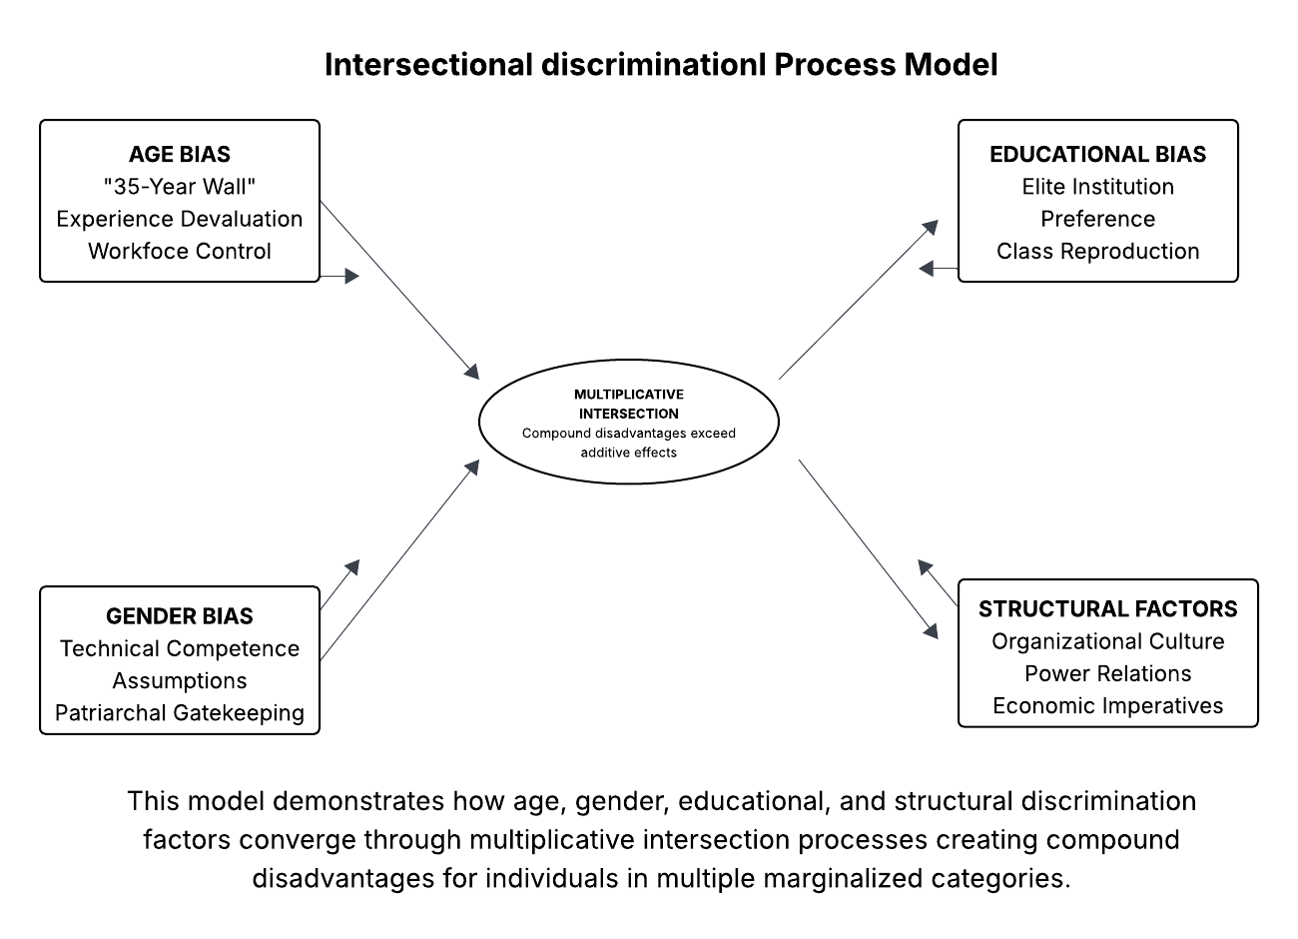
The story of unmarried women with elite education bordering on 35 years, outlined by Participant E is an illustration of the theoretical projections of Collins et al.(2021) concerning the issue of intersectional effects:
"Elite education for women signals threatening competence rather than desirable capability, creating compound disadvantage that men with identical credentials don't face." [Participant E]
This observation also shows the liability of achievement as it clashes with more systems of oppression than ever.
Goggin and Soldatiic (2022) report that with an intersectional analysis, the researchers get a systematic way of viewing different sources of harassment or oppression to interact instead of independently. This theoretical stance is confirmed by the current research, which will demonstrate how the complex of age, gender, and educational discrimination fulfills several hierarchy maintenance roles, all at the same time. Ageist, sexist, and classist preservation interests are met by systematic exclusion of older women from non-elite universities, at the same time as this appears to be founded on objective evaluation criteria.

Organisational Responses: Symbolic Compliance Versus Systematic Change
A critique of the organisational diversity practices shows inherent inconsistency between the discourse of inclusion and the structural demands that reproduce practices of exclusion. Ely and Thomas (2023) have found that the diversity programs may act more as legitimisation goals that are deemed to enable change. The findings of this study lend strong credence to this theoretical standpoint, providing evidence of the fact that formal policies are in place mainly to give legitimacy to an institution.
This relationship can be seen in the way participant A evaluated diversity policies, which are mere legitimacy policies:
"Written policies exist mainly for legitimacy purposes - they demonstrate good intentions without creating accountability mechanisms or measurable change requirements." [Participant A].
This observation goes in line with the argument presented by Ely and Thomas (2023) that symbolic compliance enables discrimination to remain and to get a legal and social alibi.
The differences in the effectiveness of interventions in different organisations verify the assertion by Hastings and Schwarz (2021) that discrimination reduction is based on the interests of holders of power and not ethical commitments. An effective change, as they project in their study, goes hand in hand with organisational interest as opposed to morality. This theoretical stance is supported by the current results, which demonstrate the correlation between the diversity outcomes and the business imperatives instead of interests in justice.
Figure 4 Organizational Response Effectiveness Analysis Matrix.
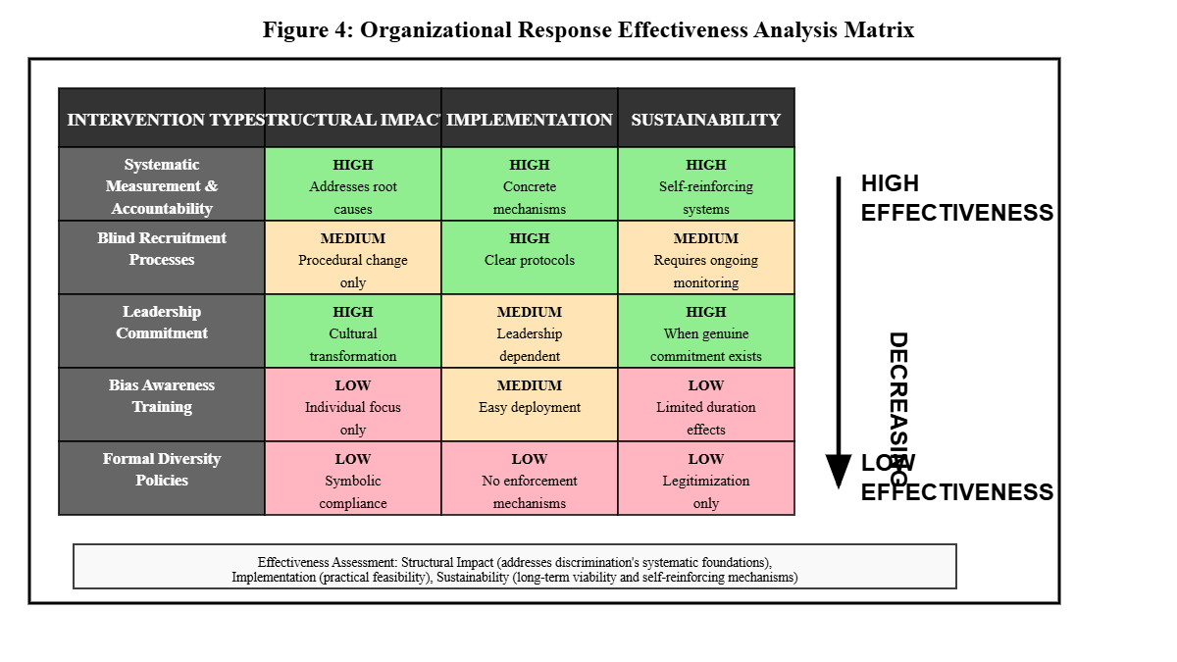
According to Davis (and DeWitt, 2021), organisational reactions to discrimination usually uphold the capitalist logics of valuing efficiency before social justice. Their analysis is confirmed by the results of this study, as it shows how even successful diversity programs define inclusion through the prism of competitive edge instead of innate rights. The drawback of a biased training program recorded in the current study is representative of the concept of individual bias orientation vs. the actuality of structural discrimination denoted by Davis and DeWitt (2021).

Theoretical Implications: Challenging Liberal Frameworks
The findings, at the most basic level, call into question liberal diversity models: the view that discrimination is either a personal bias or a market failure. Wang et al. (2024) believe that discrimination is a high-end reproduction mechanism of social structuring that has various systematic goals. The findings of the present study empirically confirm this theoretical criticism, showing how exclusionary practices can remain in existence even when intuitively indicated to be inefficient by their structural purposes.
Systematic patterns of discrimination across decision-makers and organisational contexts cannot be determined by the psychological reductionism characteristic of the Social Identity Theory, as criticism brought up by Hassler et al. (2021). In this study, their criticism is backed as the exclusionary trends turn out to be instigated by structural, as opposed to psychological, causes. Nils Karl Reimer et al. (2022) assess that the focus on cognitive mechanisms obscures the way organisational designs provide rewarding mechanisms to discriminatory behaviour, irrespective of a person's attitude.
The epithet of efficiency in the Resource Dependence Theory, expressed by Davis and DeWitt (2021), does not take into account the ways in which discrimination promotes organisational goals, which stand above economic optimisation. This reproach is corroborated by the existing evidence of the continued social ranking, risk-reduction, and power relations through the process of exclusion, even in cases where these applications are economically ineffective. According to the identification in the article by Jiang et al. (2022), indeed, the cultural construction of resource valuations underestimates the contributions of marginalised groups and overestimates the capabilities of dominant groups in a systematic way.
According to Connelly et al. (2024), Signalling Theory places significantly too much emphasis on information asymmetry as the problem rather than information problems that occur due to a signalling mechanism bias against some of the parties. The findings of this study agree with their critique in demonstrating the systemic advantage of dominant groups in signal interpretation processes through the supposedly objective credentialing requirements, which disproportionately hurt the marginalised populations.

Comparative Global Context
The comparative analysis exposes the institutional arrangements' effects of discrimination expression, but within the scope of replications and delivery of similar social reproduction functions of various forms of technological capitalism. Baker and Welter (2024) affirm that Chinese tech companies are exposed to a cultural and institutional environment that normalises discriminatory behaviours to a high degree, as compared to Silicon Valley organizations that experience greater regulation.
In support of this argument, Jiang and Murmann (2022) state that Chinese state-led capitalism has greater freedom to express discriminative behaviour since there will be a lack of pressure, unlike in market-driven capitalism in the United States. Their analysis is corroborated by the findings of this study, which indicates the manner in which the systematic exclusion process works even more visibly within a Chinese contextual environment as compared to the more subtle discrimination in a Western one, yet achieves similar goals (hierarchy maintenance).
As Heidi Wiig Aslesen et al. (2023) explain, the European examples of a social market economy show other examples of combining social cohesion with technological evolution. In an aspiration to automate the world, they find the culture of inclusive practices developed by Nordic technology companies interesting since they balance innovative potential and performance, and do not necessarily represent the essence of the technological industry, but the institutional decision-making.
However, Wang et al. (2021) observe the patterns of convergence in discrimination in diverse technological environments, which shows systematic forces in technological capitalism to reproduce inequality despite national variations. Their analysis is informed by their study of the findings of this study, which shows that competitive pressure and technological change bring about the same sort of exclusionary trends in institutional settings.

Chapter Six: Conclusion & Practical Implications

Critical Summary: Structural Foundations of Discrimination
This study provides a different understanding of employment discrimination as an aspect of individual bias to structural reproduction systems, which demonstrates various roles exclusionary practices are playing, so that they cannot be eradicated, despite being unproductive. The detailed study by Wang et al. (2021) indicates that discrimination is one strategy used by the Chinese technology companies to maintain a hierarchy, preserve cultural homogeneity, and economically exploit people. The results of this study have empirical support for this theoretical framework, but also expand the knowledge of the complexity of intersectional discrimination.
When one considers the phenomenon of the 35-year wall, it is clear that age discrimination as a means through which the workforce is often controlled can satisfy the economic interests of various entities. The systematic exclusion based on age that is developed as stipulated by Stypinska (2022) operates by institutionalised cultural standards, which give high importance to perceived adaptability instead of amassed knowledge. The study supports and builds upon the analysis provided by Stypinska, showing how age discrimination enhances the process of wage depression, flexibility of workforces, and maintenance of cultural homogeneity, as these processes may be more or less rational by innovating language constructs.
It is enough to mention that gender discrimination does not subsidize regardless of how high women have attained in relation to education, which is a symptom of patriarchal adaptation outlined by Liu (2024). This interrogation of the women in terms of technical abilities explains how masculine power in the technical profession is, in turn, perpetuated through some of the more opaque forms of exclusion that are easy to deny but can effectively block off the chance to move up the career ladder.
Discrimination in education is a form of class reproduction that creates a logic of equality by the ideology of meritocracy, through which it also disadvantages those likely to be qualified who are not in advantaged backgrounds. Other researchers indicate that credentialing systems achieve the purposes of social sorting instead of quality evaluation, as they recreate the hierarchies of classes by establishing a pretense of purely objective forms of selection (Lu et al., 2022). The outcome of this study stands with a good empirical backing of this theoretical position.
Answering Research Question 1: Systematic Social Reproduction Mechanisms
How do age, gender, and educational discrimination function as systematic social reproduction mechanisms in Chinese technology companies' recruitment processes?
The study shows that discrimination works by three reciprocally linked systematic processes, which are beyond individual prejudice. Regarding the question of the purpose, the author argues that age discrimination acts as an organisational culture maintenance system with a primary focus on perceived adaptability and with economic management motifs (Stypinska, 2022). This paper has demonstrated a systematic exclusion of experienced workers through the wall of 35 years of age of workers as a means to ensure wage discipline and flexibility of the workforce in accordance with large-scale capital accumulation interests, but not out of concerns of actual performance.
The modality of gender discrimination is a kind of patriarchal adaptation mechanism proposed by Liu (2024), which ensures that the culture of masculine superiority is maintained even under transformative education demographics. The results reveal that the technical ability and expertise of women are systematically challenged, whereas the same abilities of men are not similarly challenged, illustrating how patriarchal systems bend to accommodate the systems of power and uphold them, even as they appear as merit-related.
The educational discrimination circulates between capital, which operates a dynamic of the reproduction of cultural capital as explained by Lu et al. (2022), whereby the preferences in institutional prestige are assigned functions of group sorting and not of ability evaluation. The institutional quest to favour highly qualified graduates through reputation, not their performance, shows how credentialing systems support social stratifications by allocating the most recognized and valued items in the system, the at-first-glance objective selection.
The mechanisms combine so that they can layer various roles in the social reproduction of society: economic exploitation, which involves the suppression of wages and control over the working population; cultural homogenisation, which comes with the systematic exclusion of alternative voices; and social stratification in the form of the masking of systematic inequality by the ideology of merit.
Answering Research Question 2: Intersectional Discrimination Effects
How do intersectional discrimination effects create compound disadvantages that reveal the inadequacy of single-axis theoretical frameworks and intervention strategies?
Research by Collins et al. (2021) has found that, despite the interaction term typically adding the effects of each dimension in an intersectional discrimination, there are also synergistic effects, resulting in the production of qualitatively very different experiences that are beyond the capabilities of the single-axis approaches. The study offers empirical support to this theoretical stance by showing how the systems of oppression combine to drive compound disadvantages that are greater than the simple summation of individual discrimination effects.
Intersectionality is manifested in the experience of women nearing 35 years old with elite education. Instead of believing education is beneficial, it is a liability when it is incompatible with expectations of ageism and sexism at the same time. As deduced during participant experiences, elite education is a message of threatening competence to women as opposed to desirable capability, which introduces cumulative obstacles that cannot be experienced by men with the same qualifications.
The article by Goggin and Soldati (2022) stresses that intersectional analysis discloses systematicity that is involved in interactions between the forms of oppression and not individual instances of bias involved. This research validates their theoretical assertions, revealing how their combination of age, gender, and educational discrimination can be used to perform all or some of the hierarchy-maintaining functions simultaneously, but invariantly seemingly on the basis of objective evaluation standards.
Single-axis intervention imperfection can be identified when it comes to intersectional discrimination. The conventional diversity interventions that emphasize one or another bias are unable to think in terms of the systematic interaction of the systems of oppression and eventually fail to encompass interventions that consider only superficial manifestations and not structural bases. In their study, Collins et al. (2021) state that effective intersectional intervention needs analytical methods that fail to treat the forms of discrimination as independent phenomena and that can be subjected to systemic oppression interconnectedness.
Answering Research Question 3: Structural Contradictions in Organisational Interventions
What structural contradictions limit the effectiveness of organisational diversity interventions in addressing systematic discrimination in Chinese technology firms?
The archaeological exposes basic inconsistencies between proclaimed diversity commitments and structural imperatives that continue to affirmatively act to uphold exclusion. Ely and Thomas (2023) assert that many organisational diversity agendas are more of legitimisation strategies than agents of change, even though they open a legal and social blanket over business-as-usual systematic inequality. Their theoretical analysis is verified with this research, which proves the actual patterns of symbolic compliance.
The main structural contradiction is revealed by addressing the problem of discrimination as one of individual prejudice and not a system of social reproduction. According to Davis and DeWitt (2021), the bias training programmes presuppose the existence of discrimination due to the personal insensitivity of the striking agents instead of systematic set-ups that are designed to fulfil organisational roles. This root-cause misdiagnosis guarantees failure of the intervention since it treats a wrong level of analysis without taking into consideration structural incentives towards non-stop exclusion.
Hastings and Schwarz (2021) explain that discrimination reduction should be based on the interests of the holders of power, but not ethical engagement and efficiency. Their analysis is backed up by the results of this study, which demonstrates the dependence of diversity results on business needs instead of justice concerns. The desire to be inclusive seems to coincide with the competitive advantage criterion of organisations, which indicates that structural alignment of incentives is required in systematic change, as the stance of inclusion is not upheld as a basic right.
Another structural contradiction will take the form of a gap between measurement and accountability. Its formal policies are just to appear legitimate, but they do not make systematic accountability systems or consequence systems that can potentially confront any discriminatory practices that have wider organisational roles to fulfil. Based on the research findings, there are no powers and incentives in the HR departments to question discrimination that can be used to maintain a systematic hierarchy.
The pressure brought about by the external environment becomes an important factor in the real change, which opposes the claims that corporate social responsibility is effective. The similarity of two cases of foreign-invested companies dealing with international criticism and local ones that have to work under less strict external pressure proves the thesis of how the system should change because it needs the outside accountability standards rather than the inside sense of morale.

Theoretical Contributions and Practical Implications
This study is relevant to the field of critical discrimination theory as it shows how the exclusionary practices follow the form of advanced forms of social reproduction that cater to the systematic multiple purposes at once. Intersectional analysis shows that the systems of oppression synergise but not additively, amassing the disadvantages such that they result in compound disadvantages that can only be analysed in ways that cut across single axes of analysis.
These results invalidate liberal views of diversity that imagine discrimination with respect to individual bigotry or competitive market failures, showing instead how the exclusionary processes in themselves play structural roles such as sustaining hierarchies, preserving homogenous cultures, and making possible exploitation of economic resources. This realization requires intervention methods that deal with the structural roots of bias as opposed to manifestations of bias on the surface (Collins et al., 2021).
Realistically, the study explains the reasons that ordinary programs on diversity miscarry and highlights the need for systematic change. As the analysis predicts, it would be an ultimate transformation that resorts to means of incorporating structural incentives, aligning with the interests of dominant groups as opposed to challenging structures of privilege. This practice requires external accountability systems, systems of consequence, and regulatory systems that surmount organisational inertia sustaining exclusionary practices.
Figure 5 Critical Intervention Hierarchy Framework.
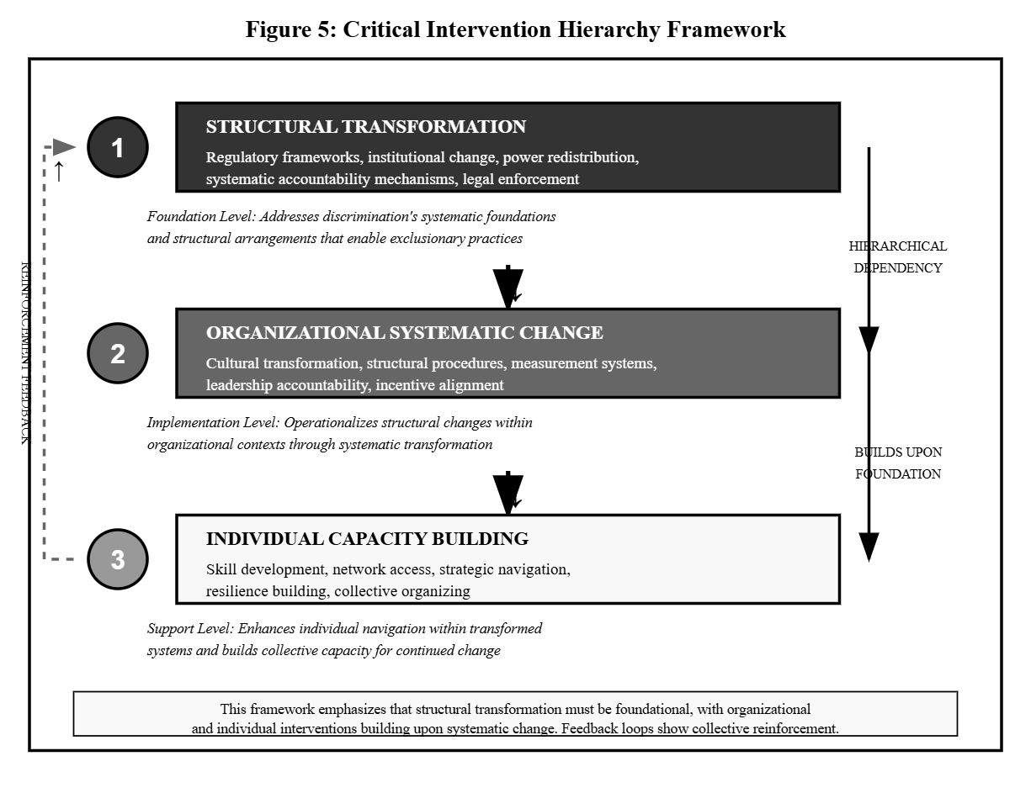
It is apparent in the study that voluntary corporate diversity initiatives are intrinsically not sufficient to respond to systematic discrimination, which played a more comprehensive social reproduction role. Making the necessary changes needs regulation, pressure exerted by the stakeholders, and a modality of accountability that introduces tangible costs to discriminatory behaviour and a systematic reward to inclusive practice.

Future Research Directions and Final Reflections
Future studies ought to further critical thinking on the structural basis of discrimination by conducting longitudinal research with a view to analyzing processes of adaptation of exclusionary practices with regard to regulatory pressures and social pressures. International comparison of the various versions of technological capitalism would also shed more light on the matter of how institutional arrangements affect the expression of discrimination carrying the same functions of social reproduction.
An economic analysis examining the costs and benefits of discrimination considered over the various stakeholders would question efficiency assumptions and reveal systematic operations that ensure the perpetuation of the practice of exclusionary practice even in situations where the practice is economically irrational. Research that focuses on analysing the cases of actual transformation success would reveal such structural conditions that supported real change instead of mere compliance.
This study shows that one cannot deal with employment discrimination without conceptualizing the exclusionary practices as regular social reproduction processes instead of issues of individual prejudice. The fact that the presence of discrimination in Chinese technological companies persists even amid its competitive pressures and talk of innovation demonstrates larger contradictions in technological capitalism that allow inequality to continue to reproduce in the face of economic growth.
These results call into question the assumption of technology as a means of democratisation, as they demonstrate that the complex reproductions of inequality which characterise systematic reproduction of inequality may be observed in digitalisation processes when structural conditions are not transformed. Such realisation requires deliberate intervention to attain the potential of technological progress to accompany the aims of social justice, as compared to mechanically expecting democratisation by the market.
Finally, to defend against employment discrimination, it is necessary to develop comprehensive change policies in the context of employment hierarchy sustaining mechanisms as opposed to only superficial manifestations of prejudice. The focus on evidence-based approaches and processes as well as innovation that exists within the technology industry provides outstanding opportunistic advantages when it comes to spearheading efforts to incorporate more systematic approaches towards systematic change, though in order to capitalise on this one must look beyond liberal diversity models to a more critical mindset that investigates and deconstructs the systematic basis under which the ability to reproduce inequality exists within the technological advancement contexts.

Reference list
Baker, T. and Welter, F. (2024). Silicon Valley entrepreneurship – Revisiting a popular dream. Journal of Business Venturing Insights, 21, pp.e00466–e00466. doi: https://doi.org/10.1016/j.jbvi.2024.e00466.
Barney, J.B., Ketchen, D.J. and Wright, M. (2021). Resource-Based Theory and the Value Creation Framework. Journal of Management, [online] 47(7). Available at: https://journals.sagepub.com/doi/abs/10.1177/01492063211021655.
Canton, H. (2021). International Labour Organization—ILO. The Europa Directory of International Organizations 2021, pp.333–338. doi: https://doi.org/10.4324/9781003179900-49.
Collins, P.H., da Silva, E.C.G., Ergun, E., Furseth, I., Bond, K.D. and Martínez-Palacios, J. (2021). Intersectionality as Critical Social Theory. Contemporary Political Theory, [online] 20(3), pp.690–725. doi: https://doi.org/10.1057/s41296-021-00490-0.
Connelly, B.L., Certo, S.T., Reutzel, C.R., DesJardine, M.R. and Zhou, Y.S. (2024). Signaling Theory: State of the Theory and Its Future. Journal of Management, 51(1). doi: https://doi.org/10.1177/01492063241268459.
Davis, G.F. and DeWitt, T. (2021). Organization Theory and the Resource-Based View of the Firm: The Great Divide. Journal of Management, [online] 47(7), pp.1684–1697. doi: https://doi.org/10.1177/0149206320982650.
Ely, R. and Thomas, D.A. (2023). Getting Serious about Diversity. Routledge eBooks, pp.119–128. doi: https://doi.org/10.4324/9781003247272-9.
Flick, U. (2021). Doing Interview Research: The Essential How To Guide. Doing Interview Research, [online] pp.1–100. Available at: https://www.torrossa.com/it/resources/an/5282194.
Flick, U. (2022). The SAGE Handbook of Qualitative Research Design. www.torrossa.com, [online] pp.1–100. Available at: https://www.torrossa.com/it/resources/an/5282289.
Gërxhani, K. and Miller, L. (2022). Experimental sociology. [online] www.elgaronline.com. Available at: https://www.elgaronline.com/edcollchap-oa/book/9781789909432/book-part-9781789909432-26.xml.
Goggin, G. and Soldatić, K. (2022). Automated decision-making, digital inclusion and intersectional disabilities. New Media & Society, 24(2), pp.384–400. doi: https://doi.org/10.1177/14614448211063173.
Guest, G., Namey, E. and Chen, M. (2020). A simple method to assess and report thematic saturation in qualitative research. PLoS One, [online] 15(5), pp.1–17. doi: https://doi.org/10.1371/journal.pone.0232076.
Gülay Türkmen (2023). Reflexivity and Positionality in Qualitative Research: On Being an Outsider in the Field. Springer eBooks, pp.145–166. doi: https://doi.org/10.1007/978-3-031-33291-3_8.
Hässler, T., Ullrich, J., Sebben, S., Shnabel, N., Bernardino, M., Valdenegro, D., Van Laar, C., González, R., Visintin, E.P., Tropp, L.R., Ditlmann, R.K., Abrams, D., Aydin, A.L., Pereira, A., Selvanathan, H.P., von Zimmermann, J., Lantos, N.A., Sainz, M., Glenz, A. and Kende, A. (2021). Need satisfaction in intergroup contact: A multinational study of pathways toward social change. Journal of Personality and Social Psychology. doi: https://doi.org/10.1037/pspi0000365.
Hastings, B.J. and Schwarz, G.M. (2021). Leading Change Processes for Success: A Dynamic Application of Diagnostic and Dialogic Organization Development. The Journal of Applied Behavioral Science, 58(1), pp.120–148.
Heidi Wiig Aslesen, Peter Kalum Schou and Hansen, B. (2023). Scaling the great wall: how women entrepreneurs in China overcome cultural barriers through digital affordances. Entrepreneurship and Regional Development, 36(3-4), pp.1–18. doi: https://doi.org/10.1080/08985626.2023.2261393.
Jiang, H., Luo, Y., Xia, J., Hitt, M. and Shen, J. (2022). Resource dependence theory in international business: Progress and prospects. Global Strategy Journal, 13(1), pp.3–57. doi: https://doi.org/10.1002/gsj.1467.
Jiang, H. and Murmann, J.P. (2022). The Rise of China’s Digital Economy: An Overview. Management and Organization Review, [online] 18(4), pp.790–802. doi: https://doi.org/10.1017/mor.2022.32.
Jiang, M. (2025). Chinese internet policies: Historical reflections and new research directions. Communication and the Public. doi: https://doi.org/10.1177/20570473251316590.
Kam, A.J.Y., Oboh, J.S., Othman, Z. and Sufian, J. (2022). The impact of gender inequality on economic growth: an explanatory sequential mixed methods study of female labour participation in the civil service. European Journal of Government and Economics, 11(2), pp.210–233. doi: https://doi.org/10.17979/ejge.2022.11.2.8951.
Kiran Marlapudi and Lenka, U. (2024). Unlocking the potential: redefining talent and competency mapping for Industry 4.0. Management Research Review. doi: https://doi.org/10.1108/mrr-07-2023-0496.
Kunisch, S., Denyer, D., Bartunek, J.M., Menz, M. and Cardinal, L.B. (2022). Review Research as Scientific Inquiry. Organizational Research Methods, 26(1), pp.3–45. doi: https://doi.org/10.1177/10944281221127292.
Liu, J. (2024). Gender-STEM stereotypes: a cross-cultural, mixed-methods exploration of women’s STEM pathways between the UK and China. [online] theses.gla.ac.uk. Available at: https://theses.gla.ac.uk/84121/.
Lu, J., Liu, Y., An, L. and Zhang, Y. (2022). The cultural sustainability in English as foreign language textbooks: Investigating the cultural representations in English language textbooks in China for senior middle school students. Frontiers in Psychology, 13. doi: https://doi.org/10.3389/fpsyg.2022.944381.
Muzari, T., Shava, G.N. and Shonhiwa, S. (2022). Qualitative research paradigm, a key research design for educational researchers, processes and procedures: A theoretical overview. [online] Available at: https://indianapublications.com/articles/IJHSS_3(1)_14-20_61f38990115064.95135470.pdf.
Nieman, S. (2023). Thematic analysis: A practical guide. Qualitative Social Work, 22(3), p.147332502311702. doi: https://doi.org/10.1177/14733250231170275.
Nils Karl Reimer, Schmid, K., Hewstone, M. and Ananthi Al Ramiah (2022). Self‐Categorization and Social Identification. Theories in Social Psychology, Second Edition, pp.273–295. doi: https://doi.org/10.1002/9781394266616.ch11.
Pimentel, T.D. (2024). A Critical Realist Model for Organizational Sociology. Critical Sociology. doi: https://doi.org/10.1177/08969205241257059.
Sayer, A. and Morgan, J. (2022). A realist journey through social theory and political economy: an interview with Andrew Sayer. Journal of Critical Realism, pp.1–37. doi: https://doi.org/10.1080/14767430.2022.2049078.
Staller, K.M. (2022). Confusing questions in qualitative inquiry: Research, interview, and analysis. Qualitative Social Work, 21(2), p.147332502210805. doi: https://doi.org/10.1177/14733250221080533.
Stypinska, J. (2022). AI Ageism: A Critical Roadmap for Studying Age Discrimination and Exclusion in Digitalized Societies. AI & Society, 38(2). doi: https://doi.org/10.1007/s00146-022-01553-5.
Wang, C., Ku, G., Smith, A.N., Edwards, B., Scott, E. and Galinsky, A.D. (2024). Increasing Black Employees’ Social Identity Affirmation and Organizational Involvement: Reducing Social Uncertainty Through Organizational and Individual Strategies. Organization Science. doi: https://doi.org/10.1287/orsc.2020.14659.
Wang, J., Hu, Y. and Zhang, Z. (2021). Skill-biased technological change and labor market polarization in China. Economic Modelling, 100, p.105507. doi: https://doi.org/10.1016/j.econmod.2021.105507.
White, R.E. and Cooper, K. (2022). Qualitative Research in the Post-Modern Era. Cham: Springer International Publishing. doi: https://doi.org/10.1007/978-3-030-85124-8.
Zhang, J., Jin, S., Li, T. and Wang, H. (2021). Gender discrimination in China: Experimental evidence from the job market for college graduates. Journal of Comparative Economics, 49(3). doi: https://doi.org/10.1016/j.jce.2021.01.003.

